

**Tech Saksham**

**NM - Project Report**

**“Spotify Music Recommendation SYstem”**

**“JJ College Of Engineering And Technology”**

|  |  |
| --- | --- |
| **NM ID** | **NAME** |
| au811321114025 | Sivaprakash.G |

|  |  |
| --- | --- |
|  |  |
|  | Trainer Name  Ramar Bose |
|  | Master Trainer |

**ABSTRACT**

A Real-Time Spotify Music Recommendation System. Our project focuses on developing an advanced realtime Recommendation system using state-of-the-art AI and ML techniques. Leveraging Machine Learning algorithms, the system aims to Recommended Music any age groups simultaneously. The goal is to all Over The World Different Language in music going on people..

**INDEX**

|  |  |  |
| --- | --- | --- |
| **Sr. No.** | **Table of Contents** | **Page No.** |
| 1 | Chapter 1: Introduction | 4 |
| 2 | Chapter 2: Services and Tools Required | 6 |
| 3 | Chapter 3: Project Architecture | 7 |
| 4 | Chapter 4: Modeling and Project Outcome | 9 |
| 5 | Conclusion | 18 |
| 6 | Future Scope | 19 |
| 7 | References | 20 |
| 8 | Links | 21 |

**CHAPTER 1**

**INTRODUCTION**

* 1. **Problem Statement**

The problem statement in a Spotify music recommendation system project typically revolves around creating an algorithm. The goal is to enhance user experience by providing personalized recommendations that cater to individual tastes and preferences, ultimately increasing user engagement and satisfaction with the platform.

* 1. **Proposed Solution**

Proposed Solution due to Project Involves utilization of k-means clustering for music recommendation system. Gather data on user listening history, preferences, and interactions with the Spotify platform. This could include user profiles, playlists, liked songs, skipped songs, etc.

* 1. **Feature**
* **User Profile Creation:** Allow users to create profiles and input their music preferences, including favorite genres, artists, and songs.
* **Popular and Trending Recommendations:** Provide recommendations based on popular or trending songs and artists within the users preferred genres.
* **Playlist Generation:** Generate custom playlists based on user preferences, moods, or occasions(e.g., workout playlists, chill-out mixes).
  1. **Advantages**
* **Personalization**: Tailoring music recommendations to each users unique tastes and preferences enhances the listening experience, leading to higher user satisfaction and engagement.
* **Engagement:** Interactive features such as personalized playlists, social sharing, and user feedback integration encourage users to actively participate and interact with the app, increasing overall engagement levels**.**
* **Community Building:** Social integra features allow users to share their favorite music and playlists with friends, fostering a sense of community and connection among users.
* **Revenue Generation**: Enhanced user engagement and retention can lead to increased subscription renewals.
  1. **Scope**

Continuously improving the recommendation algorithms to better understand user preferences and behaviors, potentially incorporating more advanced machine learning techniques such as reinforcement learning or deep learning. Remaining agile and adaptive to technological advancements and market trends, regularly updating and refining the recommendation system to stay ahead of competitors and meet the evolving needs and expectations of users. Tailoring the recommendation system.

**CHAPTER 2**

**SERVICES AND TOOLS REQUIRED**

**2.1 Services Used**

* **Spotify API**: Access to Spotify’s API allows you to retrieve user data, including history, favorite tracks, and playlists, and interact with the platform’s music catalog to obtain information about artists, albums, and tracks.
* **Machine Learning Libraries:** Libraries such as skill-learn, recommendation algorithms and building machine learning models to analyze user data.

**2.2 Tools and Software used**

**Tools**:

* **Data Visualization Tools:** Tools like Matplotlib, Seaborn can be used for visualizing data.

**Software Requirements**:

* **Python: Python programming using colab note book based an the AIML project implementing the recommendation algorithms.**

**CHAPTER 3**

**PROJECT ARCHITECTURE**

**3.1 Architecture**

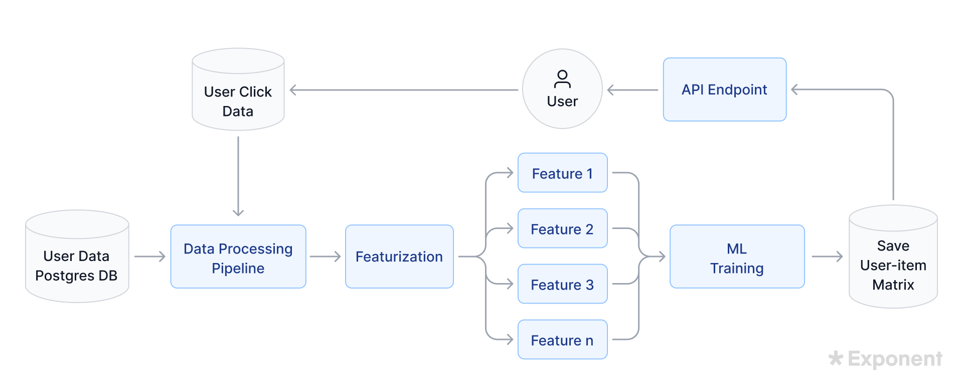

Here’s a high-level architecture for the project:

1. **Data Collection**: Real-time gather data such as listening history, playlists, user interactions, and song metadata from spotify APIs. .
2. **Data Storage**: The collected data is stored in a database for preprocess and clean collected data.
3. **Data Processing**: The stored data is processed data in a scalable and efficient data storage. .
4. **Machine Learning**: Predictive models are built based on processed data using Azure Machine Learning.These models can be human behavior, features etc.
5. **Data Visualization**: The processed data and the results from the predictive models are visualized in recommendation system in dasboard.

This architecture provides a comprehensive architecture may vary depending on the music recommendation system on the user interactions of features extraction on the attributes of approaches.

**CHAPTER 4**

**MODELING AND PROJECT OUTCOME**

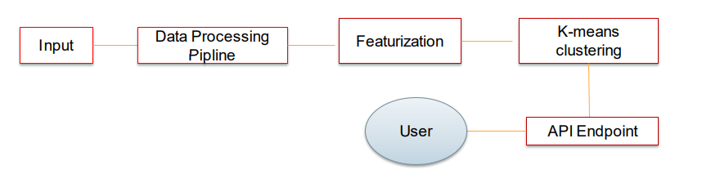

**Modelling:**

Notice that the obtain a dataset containing information about songs artists,geners, user listening history, etc.

The clean data handle missing values, and prepare it for modeling.

Choose an appropriate recommendation algorithm based on the nature of the problem.

**Evaluation:**

Evaluate the models performance using appropriate metrics such as accuracy, precision, recall, or Mean Average Precision(MAP).

**Deployment:**

Deploy the trained model to make recommendations in real-time.This could involve

integrating the model into the Spotify platform or creating a standalone application.

**Project Outcome:**

**The project outcome would be a functioning recommendation system that can generate personalized music recommendations for users based on their listening history, preferences, and other relevant factors.**

**The success of the project would be measured by the accuracy and effectiveness of the recommendations,as well as user satisfaction and engagement metrics.**

**CONCLUSION**

In conclusion, the Spotify music recommendation system project holds significant promise in enhancing the user experience and driving engagement on the platform. Through the implementation of advanced machine learning algorithms. Collaboration with industry stakeholders and ongoing innovation will be essential in staying competitive and meeting the evolving needs of users in the dynamic music streaming landscape.

**FUTURE SCOPE**

Continuously improving the recommendation algorithms to better understand user preferences and behaviors, potentially incorporating more advanced machine learning techniques such as reinforcement learning or deep learning. Continuous Innovation: Remaining agile and adaptive to technological advancements and market trends, regularly updating and refining the recommendation system to stay ahead of competitors and meet the evolving needs and expectations of users. Global Expansion and Localization: Tailoring the recommendation system.

**REFERENCES**

https://www.geeksforgeeks.org/music-recommendation-system-using-machine-learning/

# **GIT Hub Link of Project Code:**

**https://github.com/Sivaprakash200/Sivaprakash.G**